ANNEXURE
INSURANCE REGULATORY AND DEVELOPMENT AUTHORITY
Online filing of Referral Application
Instructions for filing referral applications and agreements through IRDA portal

IRDA Portal address: www.irda.gov.in
Step 1: Please enter your login and password in ‘Members login’
The home page would appear as follows:
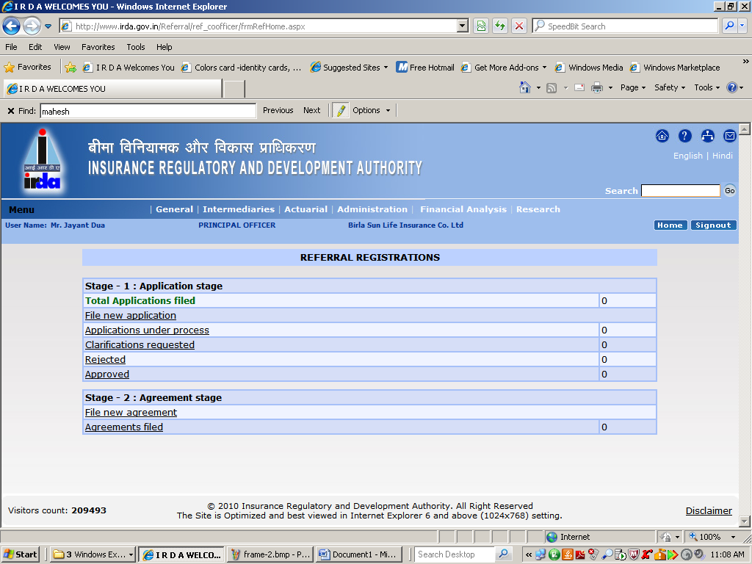
The Entire process of registration of a referral company has been divided in to two stages as detailed hereunder:

Stage: 1 Application Stage
Stage: 2: Agreement stage

STAGE I: APPLICATION STAGE
Stage I: Application Stage | 1. File new application | For filing a new referral application
 | 2. Applications under process | To view the details of applications under process at IRDA
 | 3. Clarifications requested | To view and update the clarifications requested by IRDA
 | 4. Rejected | To view the details of ‘Rejected application’
 | 5.Approved | To view the details of approved referral applications

A) Steps for filing a new application
- Fill-up the ‘Checklist for approval of a Referral Company’
- Please use <SAVE.> button to temporarily save the details.
- After filling up the checklist completely and after thorough verification, press ‘SUBMIT’ button. Please note that once ‘SUBMIT’ is pressed , you will not be able to make any modifications in the checklist
- ‘FORM-A’ button gets enabled
- Click on ‘FORM-A’, to print the form
- The duly signed ‘FORM-A’ ( generated from the portal ) with all following documents should be sent to IRDA
  - Demand draft
  - Memorandum of Association and Articles of Association
  - Audited accounts of the company for the last three financial years
  - Certificate issued by the ROC
  - Particulars of Registration with Relevant Authority (in case of banks which are not eligible for Corporate Agency License)
- Please note ‘RRN (Referral Reference Number)’ for all future correspondences.
B) To view and update the clarifications requested
Steps:
- Click on ‘Clarifications requested’ link
- Click on ‘ Referral company’ for which clarifications have been requested by IRDA
- You may see only those fields / attributes on which clarifications requested have been enabled
- Please make necessary updation
- Press ‘SUMBIT’ button to save the updated details

STAGE 2: AGREEMENT STAGE

Stage 2: Agreement stage | 1. File a new agreement | To file a new agreement
 | 2. Agreement filed | To view the details of agreement filed

The Insurer shall file the agreement in electronic form through IRDA portal within 15 days from the date of entering into such agreement

Steps for filing a new referral agreement
Steps:
- Click on ‘File a new agreement’
- Select ‘RRN’ for which agreement is required to be filed.
- Enter the relevant details in the form
- Attach the ‘Agreement ‘ in .pdf form

Note:
Please send your mail to raghavakumar@irda.gov.in for any clarifications / queries regarding the Portal under copy to the concerned Nodal Officer dealing with your Company.

******

